**Python**

I am working in Integrated Development Environment (IDE) software.

**Python Keywords and Identifiers**

**Python keywords**:

Keywords are the reserved words in Python.

We cannot use a keyword as a [variable name](https://www.programiz.com/python-programming/variables-datatypes), [function](https://www.programiz.com/python-programming/function) name or any other identifier. They are used to define the syntax and structure of the Python language.

keywords are case sensitive.

There are 33 keywords in Python 3.7. This number can vary slightly in the course of time.

All the keywords except True, False and None are in lowercase and they must be written as it is. The list of all the keywords is given below.

|  |  |  |  |  |
| --- | --- | --- | --- | --- |
| Keywords in Python | | | | |
| False | await | else | import | pass |
| None | break | except | in | raise |
| True | class | finally | is | return |
| And | continue | for | lambda | try |
| As | def | from | nonlocal | while |
| Assert | del | global | not | with |
| Async | elif | if | or | yield |

The above keywords may get altered in different versions of Python. Some extra might get added or some might be removed. You can always get the list of keywords in your current version by typing the following in the prompt.

The command how we can get all the keywords is-

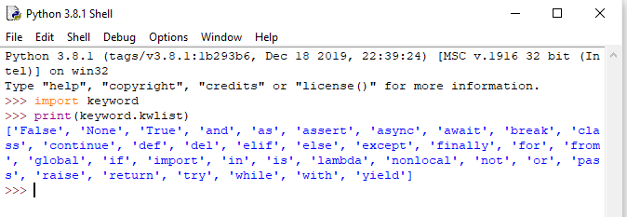

**Python Identifiers**

An identifier is a name given to entities like class, functions, variables, etc. It helps to differentiate one entity from another.

**Rules for writing identifiers**

1. Identifiers can be a combination of letters in lowercase **(a to z)** or uppercase **(A to Z)** or digits **(0 to 9)** or an underscore _. Names like myClass, var_1 and print_this_to_screen, all are valid example.
2. An identifier cannot start with a digit. 1variable is invalid, but variable1 is perfectly fine.
3. Keywords cannot be used as identifiers.

>>> global = 1

File "<interactive input>", line 1

global = 1

^

SyntaxError: invalid syntax

1. We cannot use special symbols like **!**, **@**, **#**, **$**, **%** etc. in our identifier.

>>> a@ = 0

File "<interactive input>", line 1

a@ = 0

^

SyntaxError: invalid syntax

1. Identifier can be of any length.

**Things to Remember**

Python is a case-sensitive language. This means, Variable and variable are not the same. Always name identifiers that make sense.

While, c = 10 is valid. Writing count = 10 would make more sense and it would be easier to figure out what it does even when you look at your code after a long gap.

Multiple words can be separated using an underscore, this_is_a_long_variable.